UNION COUNTY COVID-19 RESPONSE
WRAP RESOURCES ILO KAJIN Majel̗.

Ñan adwōj bōk dedo in COVID-19, jej aini meḷeḷe ko otemjej ñan jipan jukjuk in pikōt ājmour im ial̗ non jipan ilo tōrein ebin. Jouj im jeḷā bwe emaron̄ jabwe im jej ajej ekkar ñan jon̄an tilmaake.

FIÑANCIAL ASSISTANCE
Program kein ilal̗ rej kwal̗ok jikin jipan̄ ikijjeen oṇāān rent, jarom, food stamps im jipan̄ ko rej itok jen program in rej nae etan TANF (Temporary Aid for Needy Families). TANF program ej jipan̄ baam̗le ko m̗we edik oṇāān aer kōḷḷā ikijjeen jāān ñan kabbwe aikuj ko an baam̗le eo.

- Temporary Aid for Needy Families, SNAP (formerly food stamp)
Department of Human Services (DHS) 541-963-4113
- Rental and Utilities Assistance
Community Connection 541-963-7532

- Rental and Utilities Assistance
E.O.C.I.L. 1-844-489-3119
FOOD BANKS (Schedules and availability differ - call for details)
Ijen̗e ilal̗ ej kwal̗ok jikin ko ilo Union County m̗we rej ajej mona ñan jukjuk in ped ko ñan adwōj jim̗or bōbrae ñūta. Jouj im kūr ñan er ñan kajjitōk kon ewi wāween kilen kab iien ko rej ajej mona kein. Jouj im bareinwōt loloorjake am kajelaik er ne kwonaaj aikuj ri bo̗kwōj men ko kijem̗ ñan kwe ilo am ped ilo quarantine ak mo ñan m̗akūtkūt.
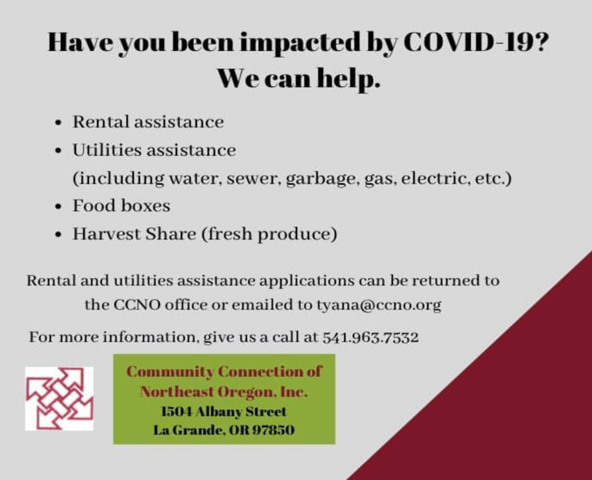
- Community Connection (541) 963-7532
- Cove Food Bank (541) 910-1810
- Elgin Food Bank (541) 910-4585
- Neighbor’s Together (541) 963-9126
- North Powder Food Bank (541) 898-2146
- Salvation Army (541) 963-4829
- Union Food Pantry (541) 805-4765
- Meals on Wheels (541) 963-7532

Online Wōtar M̗we Jemaron̄ Pekabi
Emaron̄ kon̗ adwōj ṃōṃakūt ñan jikin wia mona, rujān bwe jen wia ilo online, ak pekab im e bōk ilo mon wia ko non jipan̄ katōḷọk doon non bōbrae nan̄inmej in. Ewor ruo mon wia ilo Union County ñan am maron̄ wia mona online im pekabi.

- Safeway, 2111 Adams Ave, La Grande, OR
Wōtar online ilo www.safeway.com
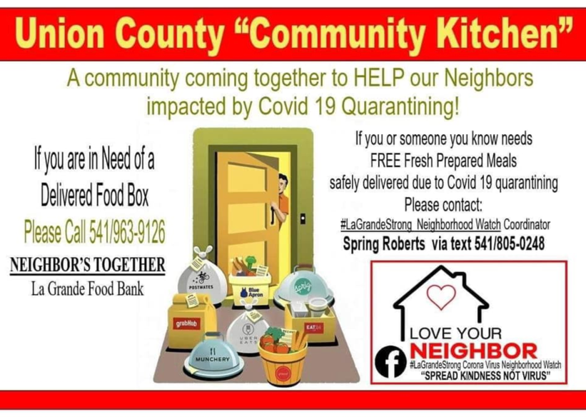
- Market Place Fresh Foods,1912 Fourth Street, La Grande, OR

https://www.marketplacefreshfoods.com/ordering/?fbclid=IwAR0UcRYk_ziOmsGcFE0VUxGsN0l0Rj8_upE_2TooOVeEg3fo_g1VQNWN9iY
- Nature’s Pantry, 1907 Fourth Street, La Grande, OR Wōtar online ilo https://naturespantry.life/order-online
- Walmart, 11619 Island Ave, La Grande, OR
Wōtar online ilo https://www.walmart.com/grocery/
Non am maron̄ wia online, jouj im l̗oor e laajrak kein:
- KOMMANE JUON AM ACCOUNT ILO ONLINE. NE EMOJ WOR KADEDE AM ACCOUNT, KAJJU DELONE.
- PUKOT MWEIK EO/KO KWOJ PUKOTE ILO AM KOJERBAL SEARCH BAR EO, AK JIKIN KAPPOK EO, NE EJJAB ETAL KAJJU ÑAN NAVIGATION BOX IM JIPEDE DEPARTMENT EO MWEIUK EO EJ BED IUMWIN.
- ATE LOK MWEIUK EO/KO ÑAN CART EO AM.
- NE ENAAJ DEDELOK, BAR ETALI MWEIUK KO ILO CART EO AM, INNEM KAJJU JIPED CHECK OUT BUTTON EO ÑAN AM KIO WIAKI MWEIK KO.
- Iloan cart eo am, komaron̄ bar kōmm̗an ukoktak ko ikijjeen jete m̗weiuk kwōj boke, joḷọk e, ak kakon̗ e ñan iliju im jekl̗aj ne kwonaaj bar wia.
- Akō ne enaaj bun būruom̗ kon m̗weiuk eo/ko ilo cart eo am ekwe wōnm̗aanl̗o̗k wot im jiped check out button eo ñan wiaiki m̗wiik eo/ko ilo am jab kōmm̗an ukoktak.
- Kāālōt juon iien eo emm̗an (raan kab awa) ñan am pick up. Kememej im loloorjake bwe kwon lukkuun jel̗a ke ejim̗we address in mon wia eo ak jikin eo kwōj pick up e m̗weiuk eo/ko am jen e.
- Kāālōt ak kanne kilen am kōḷḷā im kanne aolepen information rej aikuji ilo jikin kōḷḷā eo im bar etale mokta jen am jiped button eo ej ba “Place Order” ñan am kadedeikl̗o̗k order eo am. Emaron̄ bar lon step ko elōn lok kwōj aikuj būki ñan kadedeikl̗o̗k jerbal in order online.

Heart ‘n Home Hospice & Palliative Care, LLC
- Ejjelok wōṇāān kọọnjeḷ, jeḷāḷọkjeṇ im joñe aorōkin program in
- Call e 541-624-5800 in jikuul̗i juon iien am loḷọk armej rein rej loloorjake jerbal kein ak komaron̄ bar kōmm̗an iien am call ippāer (Am wot pepe).
- Ne kwōj kon̗an bok mel̗el̗e kon jerbal ko kōm ej kommani ilo Union Country, lale lok Facebook page eo ammim, ne ejjab call e number ne ilon̄ im kajjitōk Sherry Haeger eo im ej juon Outreach Coordinator.
- Wāween jipan̄ ñan ro im ekauwōtata nan̄inmej ko aer ilo ijoko rej ped ie – Menin jipan̄ ilo aikuj ko aer, nurse ñan jipan̄ er, bareinwōt ilo m̗weo.
- Menin jipan̄ kein ikijjeen nursing home im men ko iaerlok wot eṃōj an insurance ak Medicare bok eddo in kōḷḷāki 100%.
  - Komaron̄ dāpij wot eo physician eo am ak eo im ej lale eok
  - Medical Director ak eo im ej loloorjake am aj mour
  - Registered Nurse Case Manager
  - Certified Nurses Assistants ñan bok eddo in aj mour eo am
  - Social Worker ñan jipan̄ in lale jon̄an eo koped ie ilo aj mour eo am im kotopalpal eok ilo iien in im epen ñan kōj woj.
  - Spiritual Care Provider for Grief Support – Rijjipan̄ ilo iien būrom̗ōj ak ṃōjṇọ
- Ejjelok wōṇāān jipan̄ ko ikijjeen ro rej itok im jipan̄ ilo būrom̗ōj ak apan jekdoon ta status eo am ilo jikin aj mour.
- COVID-19 RAPID RESPONSE TEAM – Rijjipan̄ ilo aikuj ak kajjitōk ko ad ikijjeen COVID-19. Kōm ban el̗l̗ak jen kwe im aikuj ak kajjitōk ko am.
- Pukot kōm ilo Facebook: https://www.facebook.com/gohospice/
HEALTH INSURANCE INFORMATION & SUPPORT
Elon ke am health insurance? Eḷaññe kwonaaj aikuji insurance ñan kwe ak baam̗le eo, Northeast Oregon Network (NEON) ej jipan̄ ilo support ñan armej ro rej aikuj aer apply ñan insurance. Im bareinwōt wor aer rijjipan̄ ro im ewor ruo aer kajin ñan jipan̄ eok ilo jerbal kein. Ñan jeḷā elōn mel̗el̗e ko, call e
- Teresa Aguilera, Outreach and Enrollment Specialist/ Bilingual Assister ilo 541-910-0336
TRANSPORTATION SERVICES for Food & Other Errands for La Grande Residents
Ne elōn am apan ko ilo ial̗ in m̗akūtkūt, im aikuj jipan̄ ilo m̗akūtkūt in deliver, jouj im tōpar La Grande Parks & Recreation Department ilo (541) 962-1352.

Delivery Service for Food & Other Essential Items
E.O.C.I.L. 1-844-489-3119
OREGON WORKER RELIEF FUND and QUARANTINE RELIEF FUND
The Oregon Worker Relief Fund ej letok jipan̄ in jeen ñan ro im rej jokwe ilo Oregon im eṃōj aer luuji jerbal im rejjab maron̄ apply ñan Unemployment Insurance im federal stimulus relief kon wot immigration status im kio rej ioon ñūta, ejjelok jikin aer jokwe im apan aer mour.
Won ro rej maron̄ receive i jipan̄ kein? Ñan ro 18 aer iio im ritto lok im rej jokwe ilo Oregon, im rej ioon apan kein ikijjeen COVID-19 in ejjab maron̄ bōk jipan̄ kein kon wot immigration status. Jab inepata bwe enaaj safe information ko am im ban pel̗ak ñan jabdewot.
Ñan apply, kwomaron̄:
  - Kur ñan Asian Pacific Network of Oregon (APANO) ilo am call e 971-238-2186 im likūt message eo am ak kwomaron̄ bar jilkinl̗o̗k am email ilo covidsupport@apano.org.
  - APANO emaron̄ letok rijjipan̄ ñan jipan̄ ilo kajin eo kwōj kon̗an. Emaron̄ ilo English, Asian, ak kajin ko ilo Pacific Islander.
  - Kur ñan Euvalcree ilo am call e (541) 889-3189, (541) 567-1185
Euvalcree emaron̄ letok jipan̄ ilo kajin English, Spanish, & Mam languages.
VETERANS SERVICES
Center eo an Human Services ej jipan̄ veteran ro kon aikuj ko aer, kab ro im rej ped iumwin kejparok eo an veteran eo, ñan aer maron̄ bok leen jipan̄ ko rej etal ñan aolep veteran. Jipan̄ kein rej einwōt,
- Advocacy assistance for veterans and their families – Rijjipan̄ ñan veteran im baam̗le ko aer
- Rijjipan̄ ro im romelele kon apan kein ñan jipan̄ kotopalpal im kōtōprak aikuj ko an veteran ro im baam̗le ko aer ñan loloorjake bwe ren bok leen en̄taan ko aer
Ñan mel̗el̗e ko rellaplok, kūr ñan
- Brian Blais, CHD Veterans Affairs at (541) 962-8842
- Angel Smith, Social Worker ilo La Grande VA Clinic (541) 963-0627
- Rhande Shaw (for Oregon National Guard) 541-963-4221
PUBLIC, MENTAL, AND BEHAVIORAL HEALTH QUESTIONS AND SERVICES
The Center for Human Development (CHD) ej letok elōn support in jipan̄ eok kokmanmanlok āj mour eo am im emm̗anl̗o̗k eo an jukjuk in ped eo ad. CHD ej kallim̗ur ñan “ kommani jerbal ko an ilo jimwe, im emm̗an im m̗ool” eo ñan jukjuk in ped kein ad ilo ad bareinwōt jeḷā im mel̗el̗e kon m̗anit ak bwebwenato, im emm̗anl̗o̗k eo ñan Eastern Oregon.
Ej ba ilo jeje ko ilo website eo an CHD- “Privacy eo am earōk ñan kōm. Jej mel̗el̗e ke pukot jipan̄ ej juon men eo epen kōnke kwōj inepata kon won eo enaaj jeḷā kon problem ko am. CHD ej l̗ore aolep kakien ko an state im federal ñan kejparok privacy eo an juon armej.”
Ñan mel̗el̗e ko rellaplok ñan jeḷā kilen tōpar jipan̄ im support kein, kūr ñan Center eo an Human Development ilo (541)962-8800 ne ejjab visit i website ne www.chdinc.org
WIC NUTRITION PROGRAM | Mona in ājmour ñan kajojo baam̗le - CENTER FOR HUMAN DEVELOPMENT
Apañ ke am kappok mona in ājmour ñan ajiri eo/ro nejim̗ ilo tōrein nan̄inmej in COVID-19? WIC emaron̄ in jipan̄̄. Center for Human Development WIC program roj kadeḷọñ ilo 541-962-8829 ak ilo email kadams@chdinc.org
WORK & UNEMPLOYMENT ASSISTANCE - WORKSOURCE OREGON
Work Source Oregon ej juon network ñan public im private partners ro im rej jerbal ippen doon ñan jipan̄ armej ikijjeen apan ko ilo jikin jerbal im rej aikuj jipan̄ kappok jerbal, apply ñan unemployment, im bōk bar elōn katak ko ñan kilen kejparok jerbal ko aer im bareinwōt kilen bok opportunity ñan pukot wōnm̗aanl̗o̗k eo ñan kwe ilo am jerbal. Jipan̄ kein rej available ñan ro im elōn aer utam̗we, enaaj bareinwōt wor rijjipan̄ ro im ejjelok wonaer ñan jipan̄ eok ikijjeen aolep m̗akūtkūt ne kwonaaj jab lukkuun mel̗el̗e kajin pālle. Call e number kein ilal̗ ñan mel̗el̗e ko rellaplok,
- Employment Department at (541) 963-7111
- Training and Employment Consortium at (541) 963-7942
Ñan kajjitōk ak mel̗el̗e ko im jekar likjab jen i ilo list in, jouj im call e WRAP team ilo number ne 541-962-1610 ne ejjab covidwrapsvcs@union-county.org

Kōttōpar eo am ej ñan aj mour eo am ilo am ped wot ilo m̗weo imom.

