UNION COUNTY COVID-19 RESPONSE
WRAP RESOURCES

Ren ach sipwe weweiti ika sinei ei semwen COVID-19, mei wor ekkei auchean pworous me pekin aninis mi wor faniten ach ei community ika neniach an epwe anisi kich ach sipwe pochokun non ei fansoun. Mi auchea sipwe weweiti pwe ekkei pekin aninis mi aukuk ika mi chok kawoor non ekkoch fansoun.

Pekin Aninnisin mooni

Ikkei ekkei program ika neni ka tongeni angei aninis ren meon ami rent, ika meon imwemi, meon ami fifi, kaas, me konik, food stamp, me ekkewe aninis ngeni ekkewe famini mei osupwang. Ei program TANF a awora aninisin moni ngeni ekkei famini mei woor nour, mei kukkun ar pekin moni tonong mi achocho ar repwe tongeni pwisin anisir non ar famini.
- Temporary Aid for Needy Families, SNAP (formerly food stamp)
Department of Human Services (DHS) 541-963-4113
- Rental and Utilities Assistance
Community Connection 541-963-7532

- Rental and Utilities Assistance
E.O.C.I.L. 1-844-489-3119
Pekin aninisin mwenge (fansoun me kawooran ekkei mwenge-ka tongeni koko ren tichikin pworousan
Ikkei ekkei neni non Union County mi tongeni aninis ne awora ika wawu ekkei mwongo ngeni chochon ach ei community ika neniach ar resapw echik. Ka tongeni kokorir ren omw kopwe sinei kunokun me raninin ar waau ekkei mwenge. Ika en mi angei enukun omw kopwe nomwotiw non imw, kopwe esinei ngenir pwe epwe wor emon epwe waau onomw kewe mwongo ngeni neniomw.
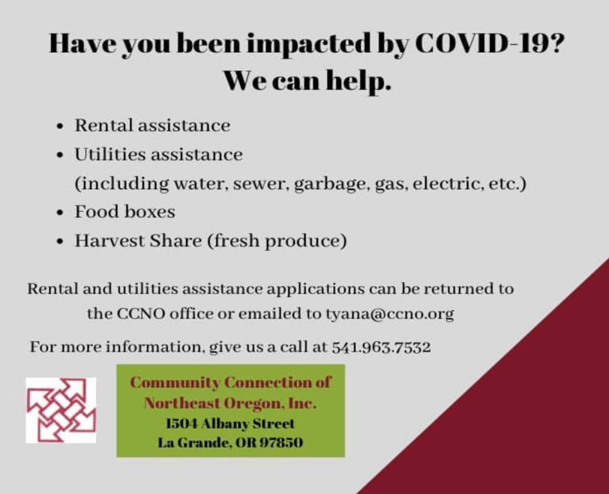
- Community Connection (541) 963-7532
- Cove Food Bank (541) 910-1810
- Elgin Food Bank (541) 910-4585
- Neighbor’s Together (541) 963-9126
- North Powder Food Bank (541) 898-2146
- Salvation Army (541) 963-4829
- Union Food Pantry (541) 805-4765
- Meals on Wheels (541) 963-7532
Pisek me mwongo ka tongeni angei mwirin kamwotiw online

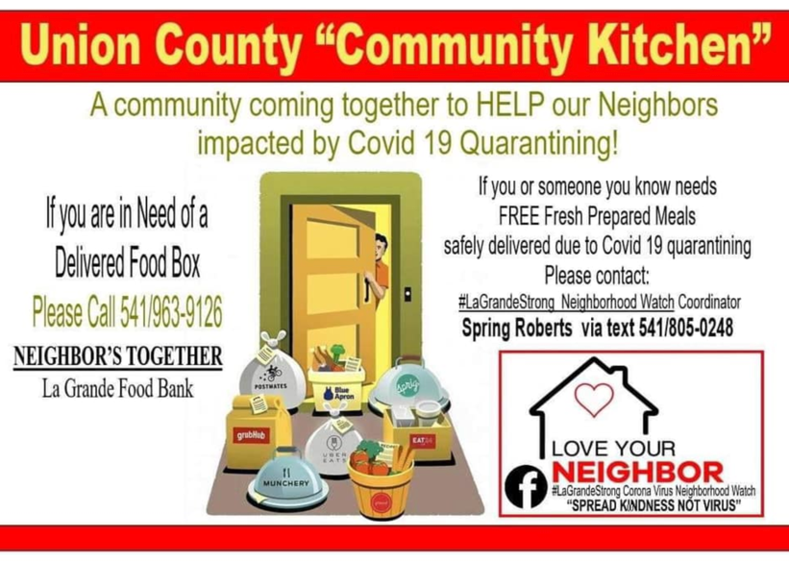
Ika mwo mi tufich ach sipwe kamo pisek ika mwongo non sitowa non ei atun corona, sia mwochen pesei ngonuk omw kopwe sotuni kamo pisek me mwongo online, ka chok tongeni no angei ika ra pwan tongeni wato non imwomw ekkei pisek me mwongo ach sipwe sopweno ne pesei ach sipwe awora amwumwuun nefinen aramas pwun epwe kukkununo cheeun me fetanin ei semwen. Mei wor ruu sitowa non Union County ka tongeni kamo ika kut onomw mwongo online iwe ka tongeni no angei me non ekkei neni.
- Safeway, 2111 Adams Ave, La Grande, OR
Shop online at www.safeway.com
- Market Place Fresh Foods,1912 Fourth Street, La Grande, OR https://www.marketplacefreshfoods.com/ordering/?fbclid=IwAR0UcRYk_ziOmsGcFE0VUxGsN0l0Rj8_upE_2TooOVeEg3fo_g1VQNWN9iY
- Nature’s Pantry, 1907 Fourth Street, La Grande, OR https://naturespantry.life/order-online
- Walmart, 11619 Island Ave, La Grande, OR
Shop online at https://www.walmart.com/grocery/

Ifa esin ach sipwe kamo online:

- Fori ew omw online account. Ika a fen wor omw account, ka tongeni sign in.
- Aea ena Search bar ika kopwe kuta ekkena metttoch ke mwochen kamo, ika fini ena department seni ena navigation pwoor.
- Amasowa omw na cart ngeni met ekkena ke mwochen meoni.
- Ika ka wes ne fini met ekkene ke mwochen meoni, pii eochu omw na cart iwe ka tiki Checkout.
- Non omw na court, en mi tongeni siwini fite ukukun met ekkena ke meoni, ika fen pwan mina seni ekkoch met kese chuen mwochen meoni, ika save ngeni minen mwirin.
- Ika ka wes me menemeneoch ren met ekkena ke amasowa ngeni omw na cart, ka tongeni tiki Check out.
- Ka tongeni fini inet kopwe tongeni angei met ekkena ke meoni. Ka pii eochu ika ena neni me kunok kopwe angei pisekumw kana mei pwung ngeni ena neni ke nomw ia.
- Ka tongeni wanong ika makeinong omw na payment method ika itan me tichikin metena kopwe kamo won. Atona eochu iwe ka tiki Place Order ren omw kopwene aweesi omw na kamo. Chechemi pwe mi tongeni epwe wor ekkoch met kopwe pwan fori anongonong won ena sitowa ke kamo non

Heart ‘n Home Hospice & Palliative Care, LLC

- Pekin eureur, kao, me evaluation ese kamwo
  - Kokori 541-624-5800 ren omw kopwe fori kunokun me ranin omw kopwe churir won telephone ika non fofoun aramas (a pwisin nonomw reomw)
  - Ika ke mwochen sinei ekkei aninis mei wor non Union County, ka tongeni katon ach na Facebook page ika kokori ena nampa ka eis Sherry, Haeger, Outreach Coordinator
- Ren aninisin ekkewe mei semwen mi nonomw non- Assisted Living, Skilled Nursing, ika ir mi nomw non imwer
- Noumw ewe insurance ika Medicare epwe meoni unusen (100%) ekkewe aninis seni hospice
  - En mi tongeni chok nouni noumw we tokoche
  - Medical Director
  - Registered Nurses Assistants for personal cares
  - Certified Nurses Assistants for personal cares
  - Social worker ir chon anisi tumwunu me emweni manawomw non ei fansoun weires
  - Spiritual Care Provider ngeni Grief Support ika aninisin netipeta
- Ese kamo ekkewe aninisin netipeta ngeni meinisin ese pwan nifinifin ar hospice status
- Free Grief Support ngeni community
- COVID-19 RAPID RESPONSE TEAM – Sise tongeni chipwang ach sipwe anisi emon
- Kuta kich won FaceBook at: https://www.facebook.com/gohospice/

Pworousen me aninisin health insurance
Mi wor noumw health insurance? Ika en me omw famini ou need health insurance, Northeast Oregon Network (NEON) a wisen awora aninis ngeni meinisin aramas mi mwochen neuneu health insurance. Mei pwan wor chon angang mei sine fosun fonuer me fonuen emen ir mei tongeni anisuk. Ka tongeni kokori,

- Teresa Aguilera, Outreach and Enrollment Specialist/ Bilingual Assister at 541-910-0336

Sein aninisin echuwa mwongo ika pwan ekkoch met mei auchea ngeni chochon non La Grande
If you have transportation issues, and need assistance with delivery services, please contact the La Grande Parks & Recreation Department at (541) 962-1352.
Ika ese wor womw nge ke mwochen emon epwe anisuk ren pekin atoura aninis, ka tongeni kokori La Grande Parks & Recreation Department won neur ei telephone (541) 962-1352.

Delivery Service for Food & Other Essential Items
E.O.C.I.L. 1-844-489-3119

OREGON WORKER RELIEF FUND me QUARANTINE RELIEF FUND
Oregon Worker Relief Fund ra awora aninisin money ngeni chon nonomw non Oregon ion ese chuen wor an angang faniten ei semwen nge rese pwan tongeni neuneu Unemployment Insurance me federal stimiulus relief pwokiten nenier ika ir chon ia, nge ra mefi echik, ese wor imwer, me weiresin osupangen mwoni.
- Ion mei tongeni neuneu ei mwonien aninis? Ion a engon me wanu ierin ika wate seni mi nonomw non Oregon mi mefi osupwang ren ei COVID-19 me ese tongeni angei ekkei pekin aninis pwokiten nenier ika ir seni ia. Ei Oregon Worker Relief Fund mei tumwun iwe meinisin pworousomw mi mwonomwonono.

- Ka tongeni apply ika sotuni:
  - Kokori Asian Pacific Network non Oregon (APANO) won neur ei telephone 971-238-2186 iwe ka watiw mefiomw ika send ngeni ei email covidsupport@apano.org
APANO mi tongeni anisuk non kapasen Merika, Asia, me fosun ekkewe fonu non Pacific
  - Kokori Euvalcree won ei telephone (541) 889-3189, (541) 567-1185
Euvalcree a tongeni anisuk ren fosun Spanish me ekkewe fosun Mam

Aninisin ekkewe ir mei piin fiti sounfiu
Center for Human Services mei awora aninis ngeni ekkewe sounfiu, mwirimwirin ekkewe sounfiu, noun ika famini en ekkewe sounfiu, noun ika famini en ekkewe sounfiu mei manaw, pwun repwe angei aninis ar repwe sotuni ekkewe aninis mei wor ngeni ekkewe ir mei piin fiti sounfiu. Ekkei aninis mei pachenong,

- Aninis ngeni ekkewe mei piin fiti sounfiu me ar kewe famini
- Ekkewe chon aninis mei weweiti weires me eppet ra tongeni anisi ne emweni ekkei ir mi piin fiti sounfiu me ar kewe famini ar repwe tongeni angei aninis mei kawoor faniter

Ren tichikin pworous, ka tongeni kokori
- Brian Blais, CHD Veterans Affairs won noun ei phone (541) 962-8842
- Angel Smith, Social Worker seni La Grande VA Clinic (541) 963-0627
- Rhande Shaw (seni Oregon National Guard) 541-963-4221

PUBLIC, MENTAL, ME BEHAVIORAL HEALTH KAPAS EIS ME PEKIN ANINIS
Center for Human Development (CHD) a awora sokopaten aninis an epwe anisuk ne eochuno manawen inisumw non ach ei community ika neniach ei. CHD a wisen awora angangeochun, kirekireochun, me watenon tumwun ngeni ach ei community ika neniach ei fiti weweochun an Eastern Oregon eereni, pworousen nonomwun, me tufichin.
Ewe mak won ewe CHD website-“Mwonomwonen pworousomw mei auchea ngeni kich. Omw angei aninis mei weires ina pwata kosapw ani noninen ika ion epwe sinei met ekkena omw osukosuk. CHD mi fiti enukun state me federal ren pekin mwonomwonen pworousen aramas. Ekkei ennuk mi mak me awewe non noun CHD we Notice of Privacy Practices”
Ika ke mwochen sinei pwan ekkoch pworous ren ekkei pekin aninis, ka tongeni kokori ewe Center for Human Development won nour we telephone (541)962-8800 ika tota won www.chdinc.org
WIC NUTRITION PROGRAM | MWONGO MEI AUCHEA NGENI INISUMW FANITEN EKKEWE FAMINI PWE EPWE WOR MAARIFICHIN INIS
En mei aturesi ne awora mwongo mei eoch ngeni inisumw me ngeni noumw semirit non ei osukosuken Covid-19? WIC mi tongeni anisuk. Ewe Center for Human Development WIC program a wisen anisi aramas ar repwe angei ei aninis. Ra tongeni anisuk won won phone 541-962-8829, ika email kadams@chdinc.org

ANGANG ME ANINISIN UNEMPLOYMENT - WORKSOURCE OREGON,
WorkSource Oregon a eimwa sokopaten neni ar repwe angang fengen ar repwe anisi aramas mei churi weires ren kuten angang, sotuni ar repwe nounou unemployment, angei sopwusopwun kaen angang me ekkoch aninisin tumwunun angang me ekkoch nifangen angangeach. Ekkei pekin aninis ra kawoor ngeni aramas mei wor ar semwen, fiti fengen me aninisin kapasen Merika ngeni ekkewe rese kon sine eoch ei foos.
- Employment Department at (541) 963-7111
- Training and Employment Consortium at (541) 963-7942
Ika mei wor omw kapas eis ika mwochen ese mak non ei toropwe, kose mwochen kokori ewe WRAP team won nour we telephone 541-962-1610 ika covidwrapsvcs@union-county.org

Pwopwun ach angang ach sipwe anisuk omw kopwe tongeni nonomwetiw non imw non pechekun!

